Laboratory Work 4: Advanced Data Querying and Filtering in PostgreSQL
Subject: Database Management Systems
Topic: String Functions, Date Formatting, Pattern Matching, and Aggregations

1. Objective
The objective of this laboratory work is to learn advanced querying techniques in PostgreSQL using Data Manipulation Language (DML) and Data Query Language (DQL). Exercises cover string manipulation functions (UPPER, REPLACE), date/time formatting and calculations (TO_CHAR, date comparisons, EXTRACT), filtering with pattern matching (ILIKE, Regular Expressions), and aggregate operations (MIN, GROUP BY).

2. Tasks & Execution

Task 1: Retrieve all airline names in uppercase
SQL Query: 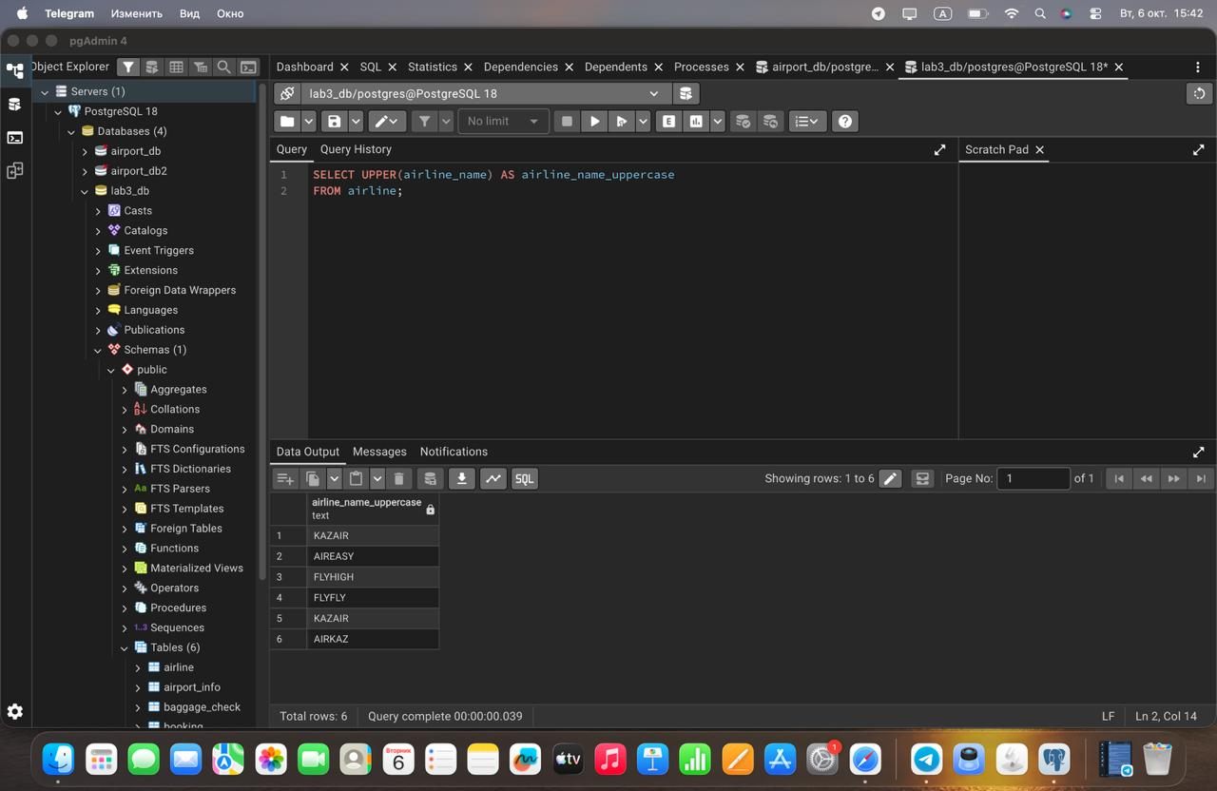

Task 2: Replace any occurrence of the word "Air" in airline names with "Aero"
SQL Query: 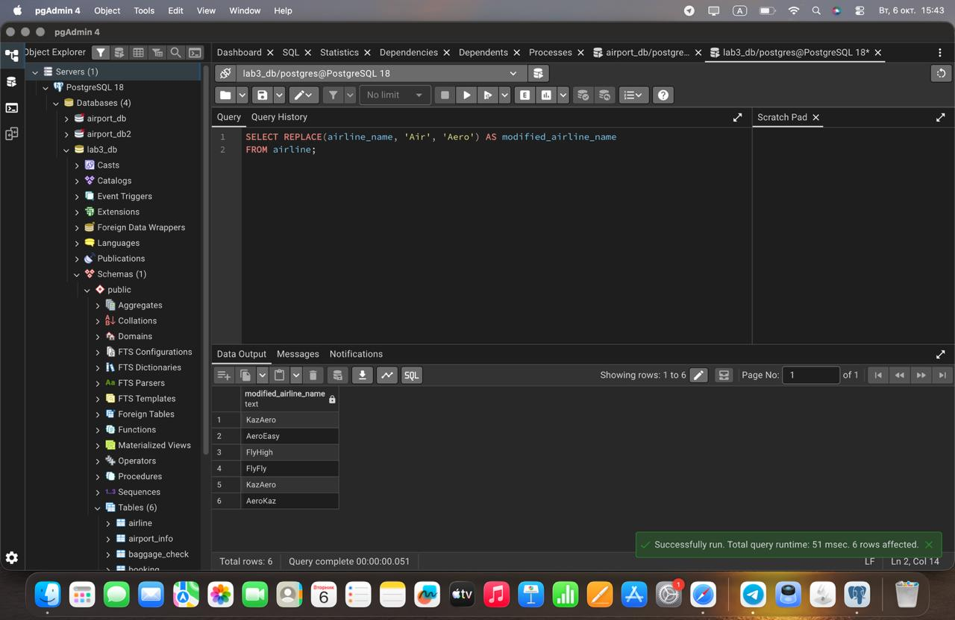

Task 3: Find all flight numbers that coordinate with both airline 1 and airline 2
SQL Query: 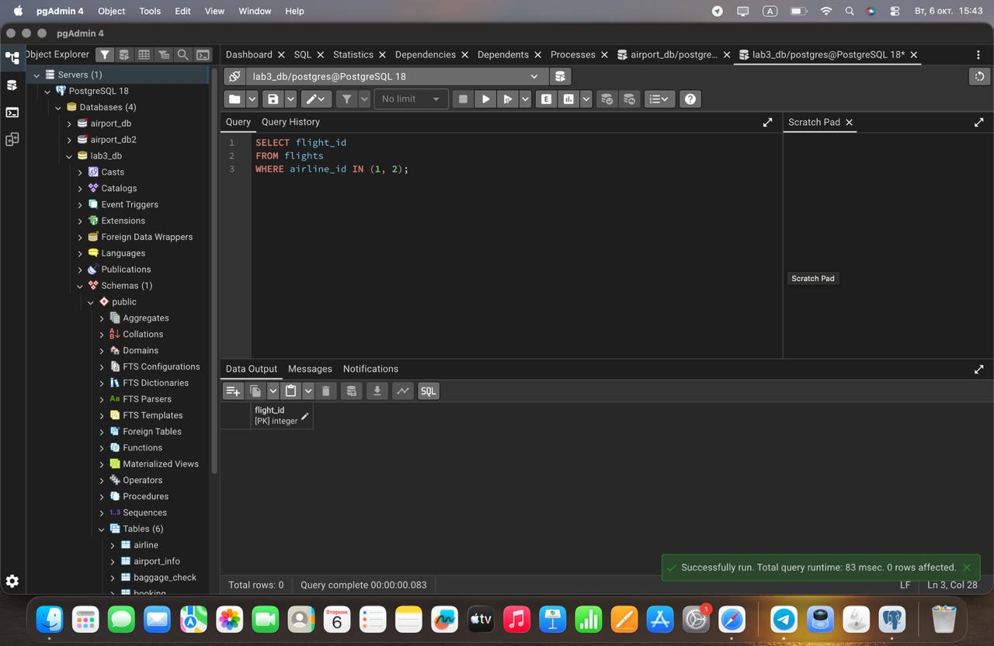

Task 4: Retrieve airports that contain the word "Reginal" and "Air" in their names
SQL Query: 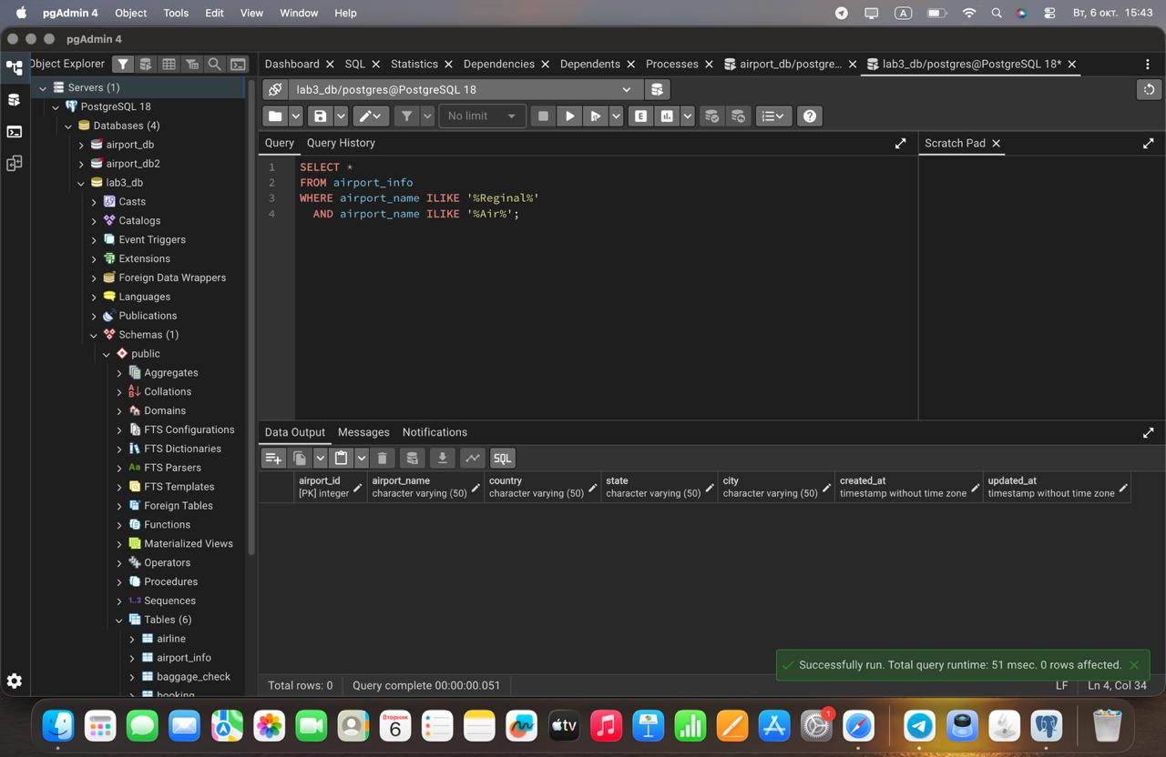

Task 5: Retrieve passenger names and format their birth dates as 'Month DD, YYYY'
SQL Query: 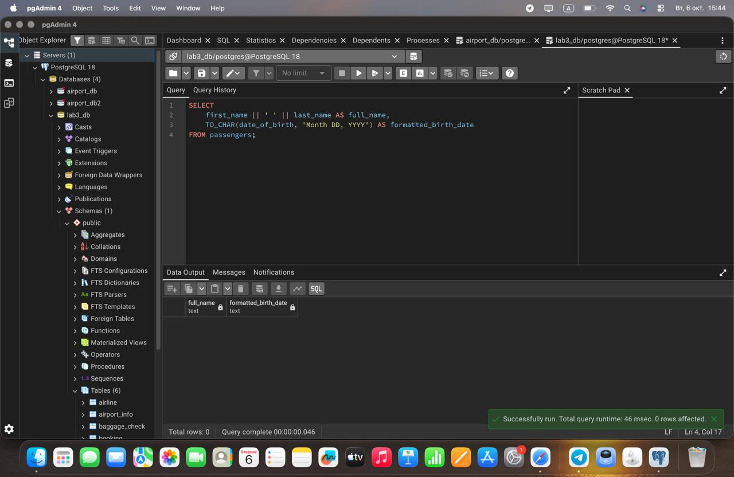

Task 6: Find flight numbers that have been delayed based on the actual arrival time
SQL Query: 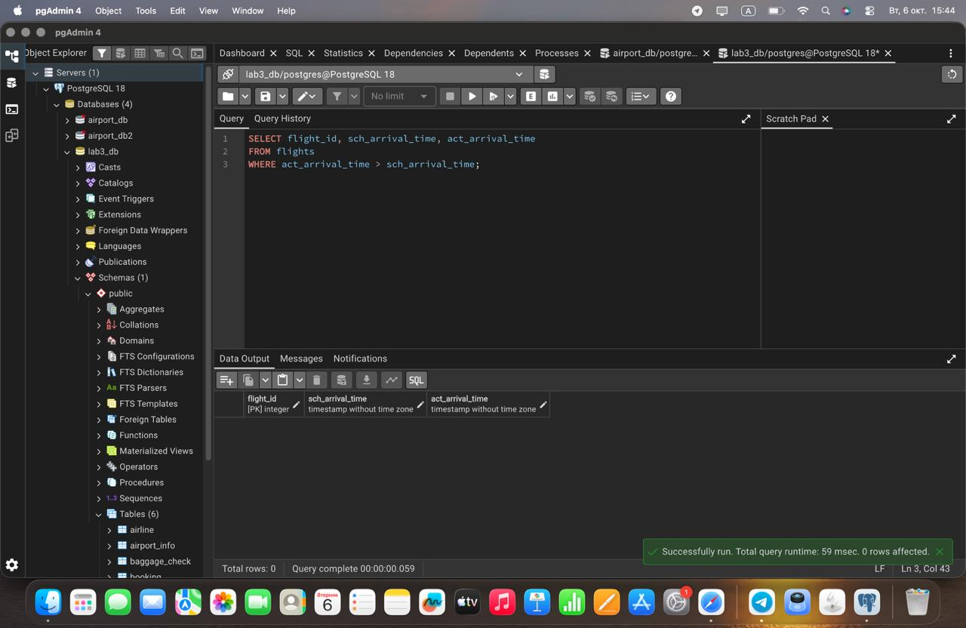

Task 7: Find flights that arrived late according to their actual arrival time compared to the scheduled arrival time
SQL Query: 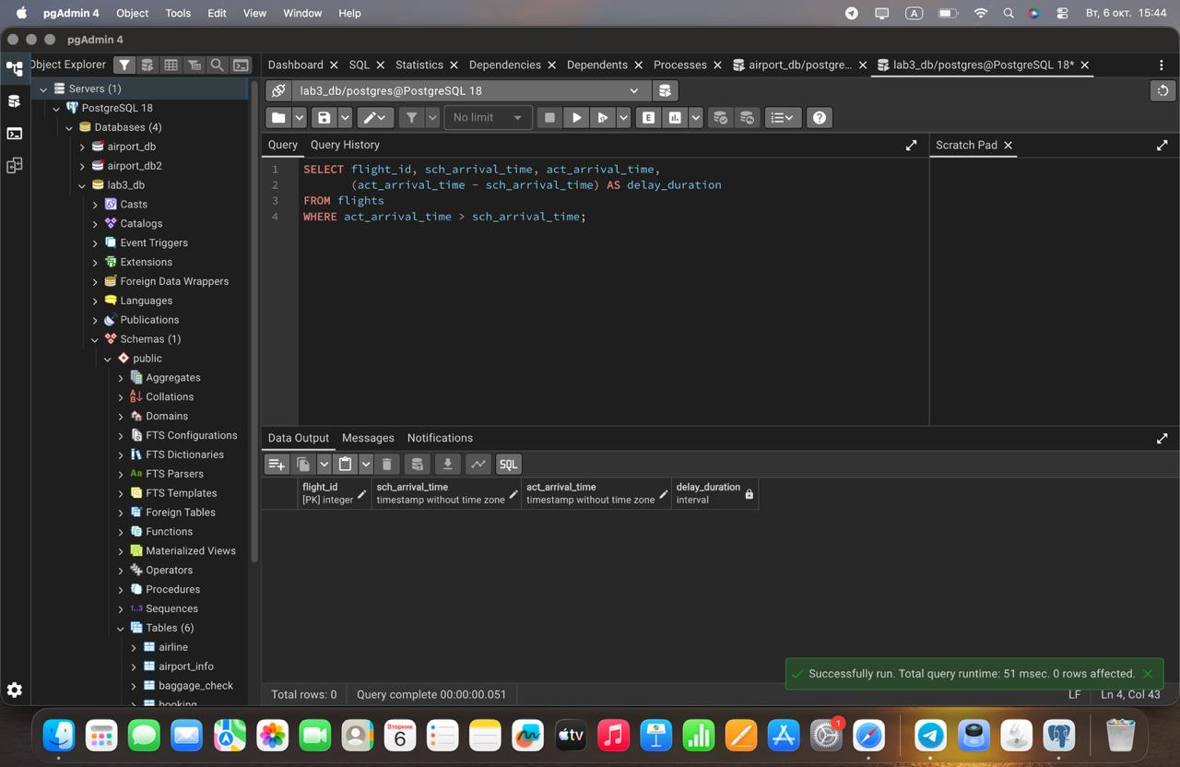

Task 8: Show airlines from any of: ('France','Portugal','Poland') created between '2023-11-01' and '2024-03-31'
SQL Query: 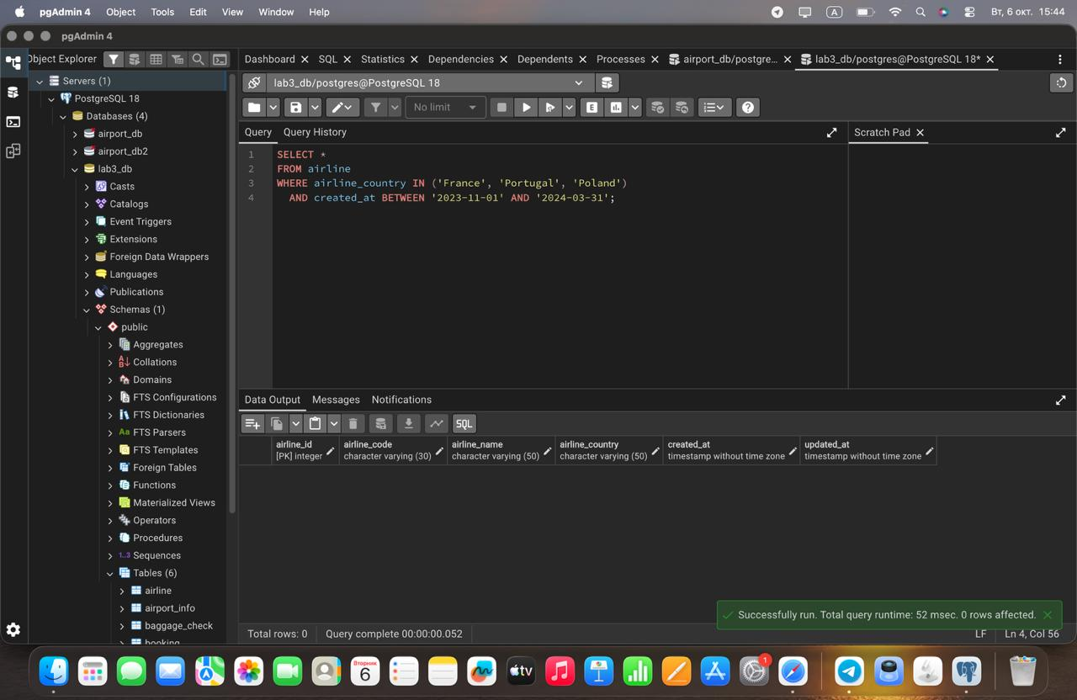

Task 9: Find top3 overweighted baggage with more than 25kg
SQL Query: 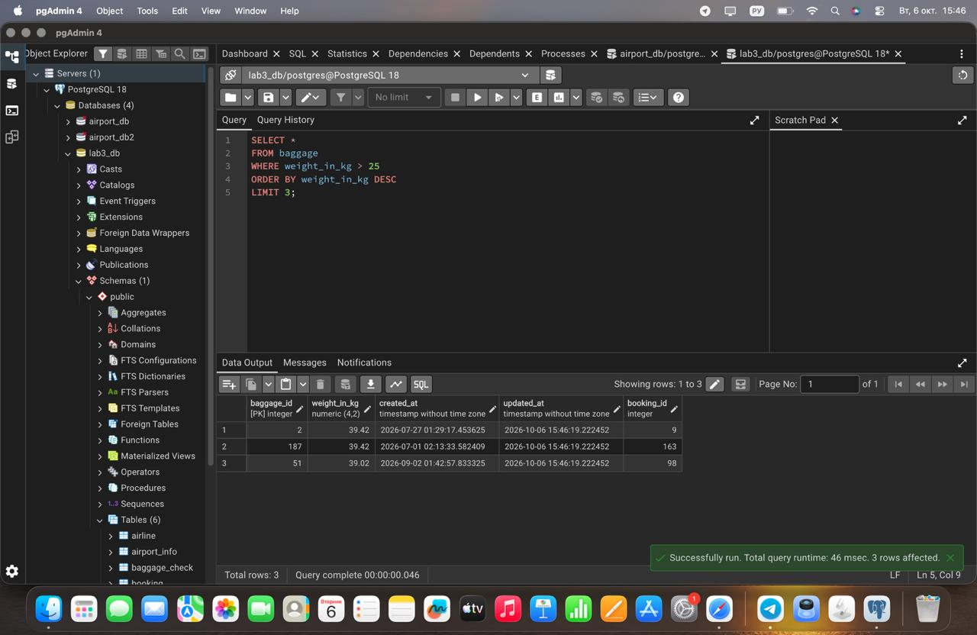

Task 10: Find the youngest passengers' full name
SQL Query: 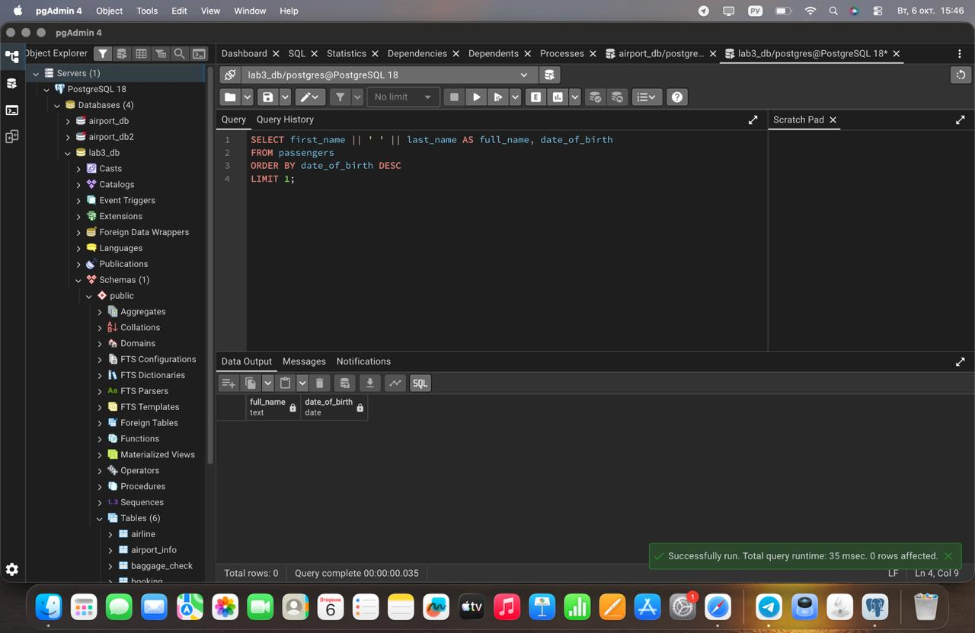

Task 11: Find the cheapest booking price on each booking platform
SQL Query: 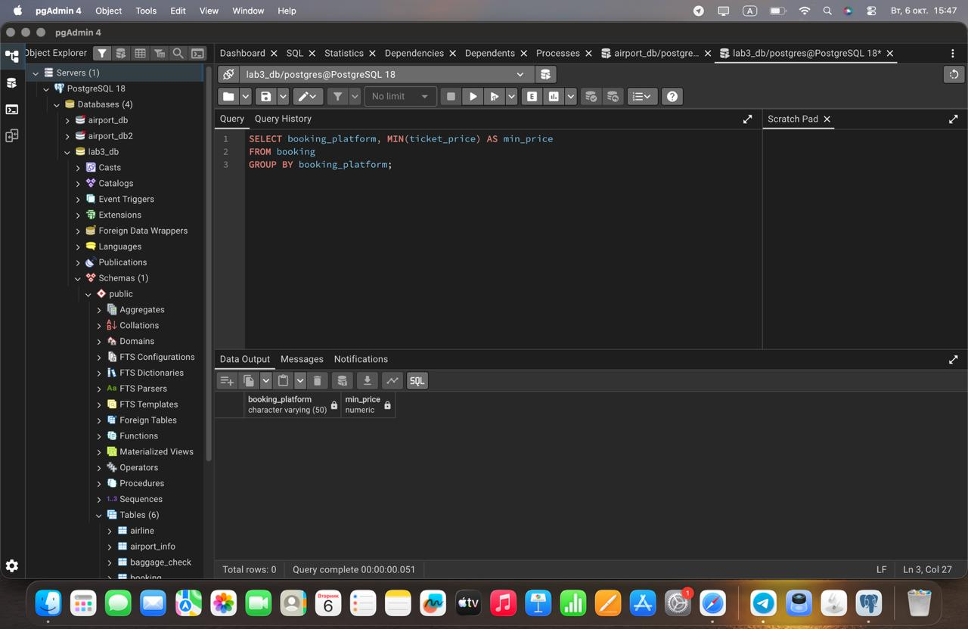

Task 12: Return airlines whose airline_code contains a digit
SQL Query: 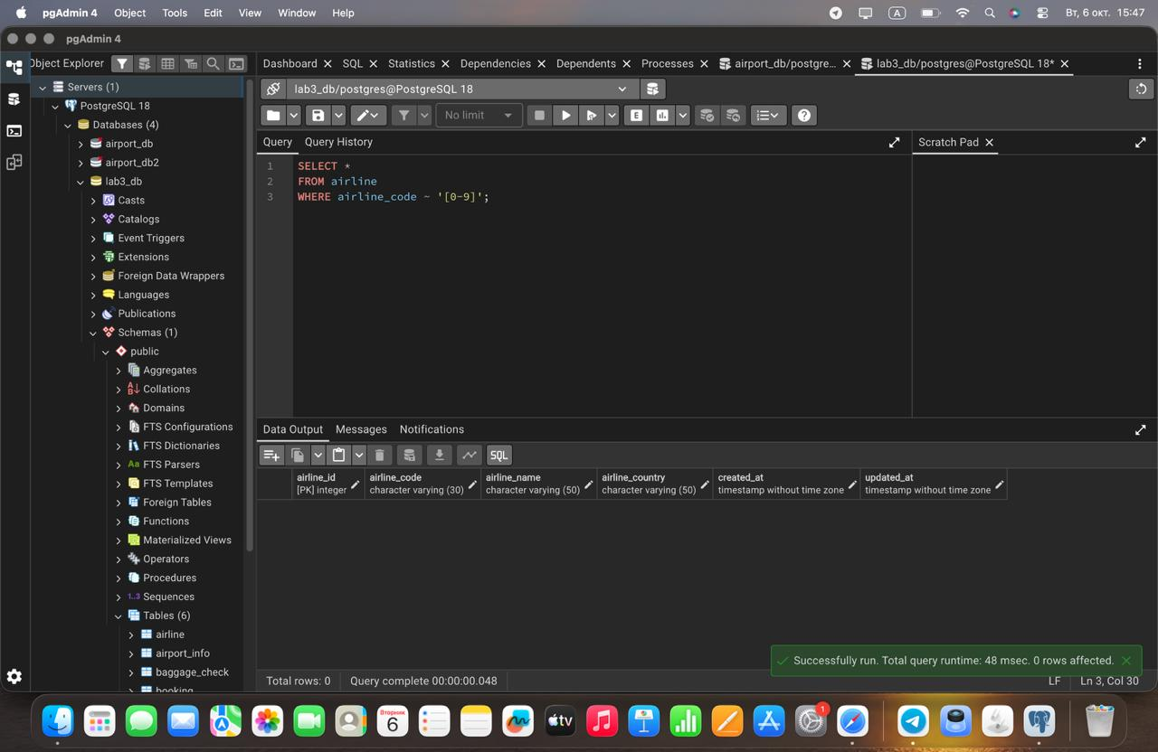

Task 13: List the top5 most recently created airlines
SQL Query: 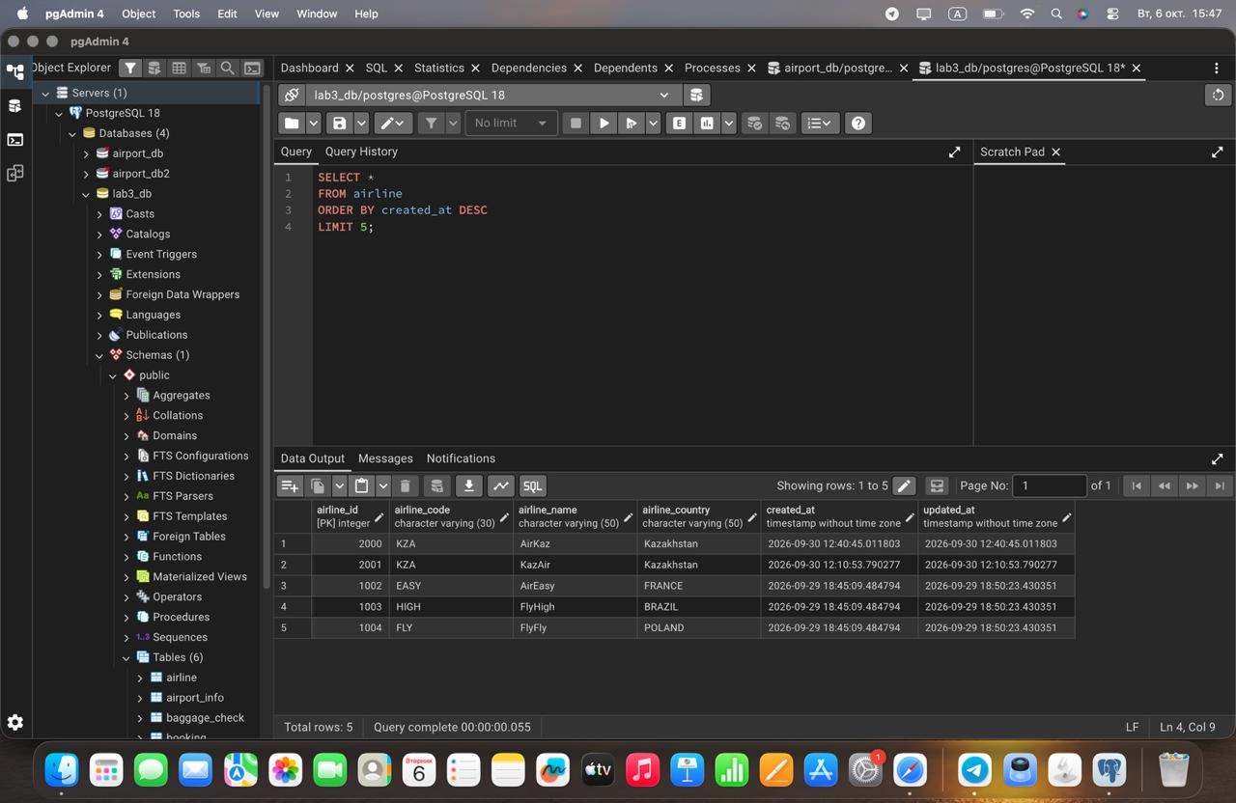

Task 14: Return all rows where booking_id is between 200 and 300 inclusive and check_result <> 'Checked'
SQL Query: 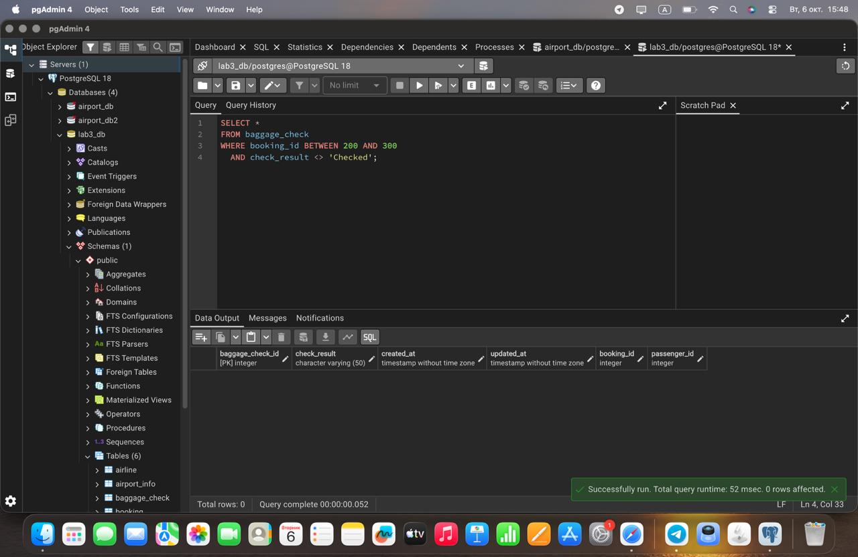

Task 15: Baggage checks where updated_at is in the same month as created_at but occurs earlier than created_at
SQL Query: 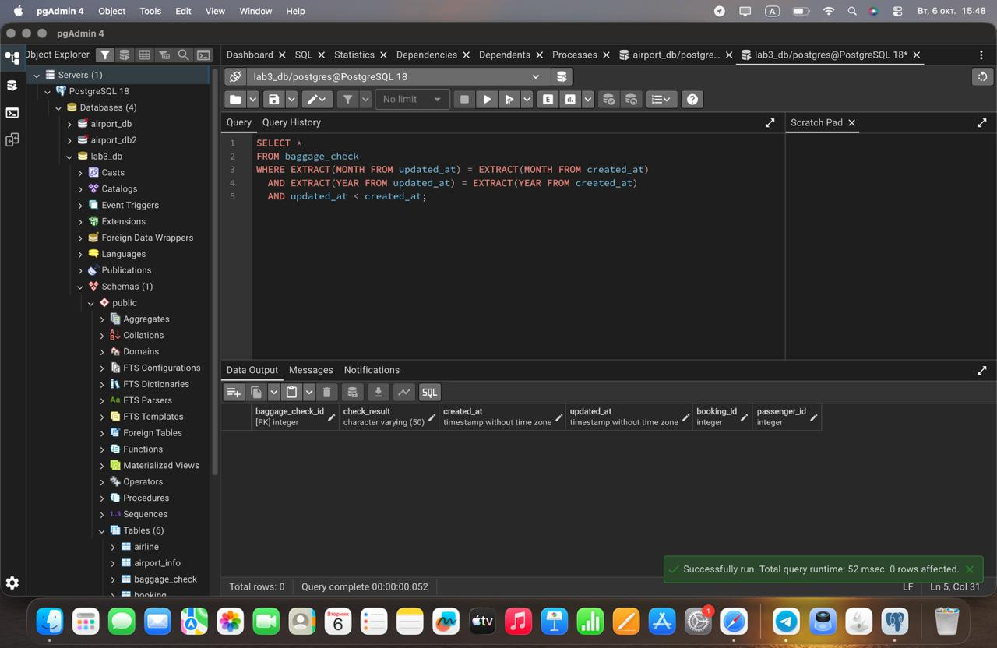

3. Conclusion
In this laboratory work, advanced querying and filtering operations were executed in PostgreSQL. Essential skills gained include string manipulation using UPPER and REPLACE, date parsing with TO_CHAR and EXTRACT, pattern matching using POSIX regular expressions (~), aggregation using MIN combined with GROUP BY, and dataset sorting with limit bounds (ORDER BY ... LIMIT).

